NexmoUpdate App

**

“Receive real-time SMS notifications for your E-commerce store wherever you are”

Contents

Introduction 3

Use Case 3

Prerequisites 3

Features 3

Steps to deploy the NexmoUpdate App 4

Create Webhook URL using NexmoUpdate app 4

Steps to use webhook URL 5

Appendix 8

Nexmo API Keys 8

Limitations 8

# Introduction

NexmoUpdate app provides extended notification feature in Shopify. Shopify admin and customers can receive notification on their mobile via SMS. NexmoUpdate app allows to send *order create, order fulfilment, order cancel, order delete* and *order payment* notifications via SMS to store admin and customers. Shopify admin can configure webhooks, which require SMS notification, and they can also set threshold amount so the notification will only be sent if the order amount satisfies the threshold value.

# Use Case

SMS to Store Owner when any new order is placed or an order status is changed on Shopify store.

Whenever any new order is placed by customer, the app will immediately send SMS to the owner with order id and the total order amount. The SMS should be sent by the app only when the order amount is more than the specified amount threshold.

NexmoUpdate App will send SMS on the occurrence of following events:

1. **Order Create**:
   1. **For Store Owner:** The order <<order_number>> is created of <<amount>> by <<first_name last_name>>.
2. **Order Fulfillment**:
   1. **For Store Owner:** The order <<order_number>> is fulfilled for <<customer name>>.
   2. **For Customer:** The order <<order_number>> is fulfilled by <<vendor_name>>.
3. **Order Cancelled**:
   1. **For Store Owner:** The order <<order_number>> has been cancelled.
   2. **For Customer:**  The order <<order_number>> has been cancelled at <<vendor_name>>.
4. **Order Delete**
   1. **For Store Owner:** The order <<order_number>> has been deleted.
5. **Order Paid**:
   1. **For Store owner:** The payment of order <<order_number>> of <<amount>> is received.

# Prerequisites

* Shopify Store account
* Nexmo subscription and corresponding Nexmo API keys (Keys and Secret). To access the API keys, see appendix section.
* Host with LAMP installed

# Features

* Send SMS on order status change
* Send SMS to both the store owner and the customer when the threshold condition is fulfilled
* Real time notification

# Steps to deploy the NexmoUpdate App

1. Go to the [***https://github.com/nexmo-apps/shopify.git***](https://github.com/nexmo-apps/shopify.git) to download the app code, as shown below:  
   C:\Users\nirav.trivedi\Desktop\Projects\Nexmo\git.png
2. Download the package by clicking on **Download ZIP.**
3. Extract the app code.
4. Host the downloaded app code using ftp or any other medium.
5. The hosted code must be accessible publically as internal and localhost will not work for this app.

# Create Webhook URL using NexmoUpdate app

1. Access the NexmoUpdate app using public URL.

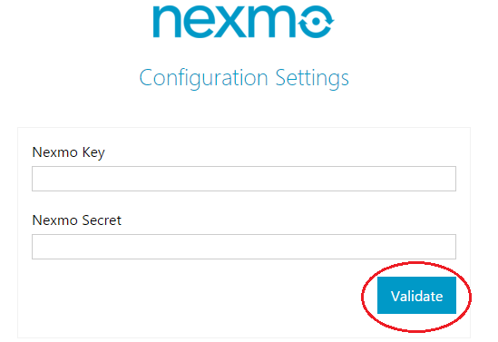

1. Provide the correct Nexmo Key and Secret and click on **Validate**.
2. The below screen will be shown on the success validation of Nexmo keys.

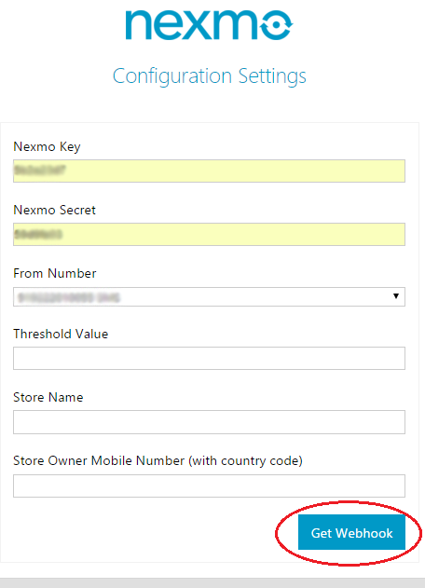

* + Select the **From Number** from the dropdown list.
  + Set the **Threshold Value** in number. It will send an SMS when any order is greater or equal to the threshold value.
  + Set the **Store Name** of online store.
  + Set **Store Owner Mobile Number** where you want to receive the message when threshold condition gets satisfied.
  + Click on **Get** **Webhook.**

1. Copy the webhook URLs which you want to integrate with Shopify events. See the screenshot below.  
   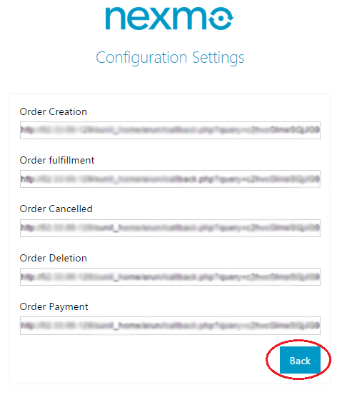
2. You can edit the webhook URLs by clicking on **Back**
3. Once you configure webhook URLs with your Shopify store app, then the SMS will be sent according to configured webhooks.

# Steps to use webhook URL

1. Login to the Shopify store admin section  
     
   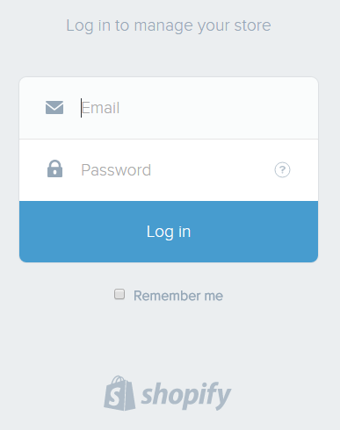
2. Successful login will lead to a menu bar in the left side of the screen. Click on **Settings**  
   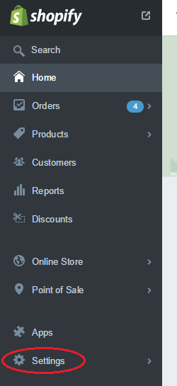
3. In the settings section, click on **Notifications**

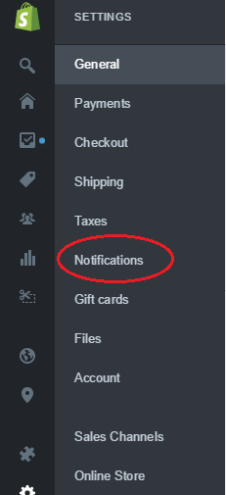

1. In the notification section, go to webhook section and scroll to the bottom
2. Click on **Create a webhook** to create a new webhook

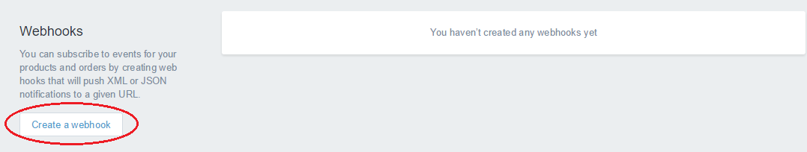

1. A dialog **Add a Webhook** will appear
2. Select an **Event** *(select only those Events which are available in NexmoUpdate app)*
3. Select Format as **JSON**
4. Paste the related webhook URL copied from NexmoUpdate app and click on **Save webhook** (It will be enabled once you have entered the URL).

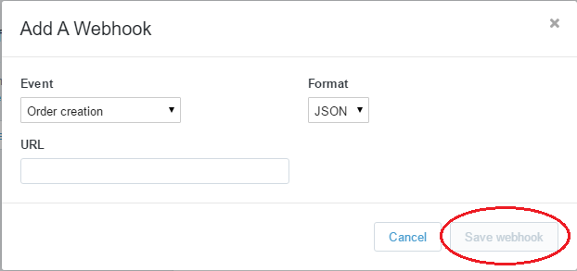

1. Once the webhook is created, you can test notifications by clicking **send test notification** and can remove the notification by clicking the delete icon.

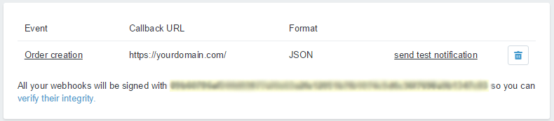

1. **send test notification** will not work for the order payment and the order delete event. They will work on live environment/test environment.

# Appendix

## Nexmo API Keys

1. Login to Nexmo
2. Click on the **Api Settings** Key and Secret will display in the top bar as shown in the below image:

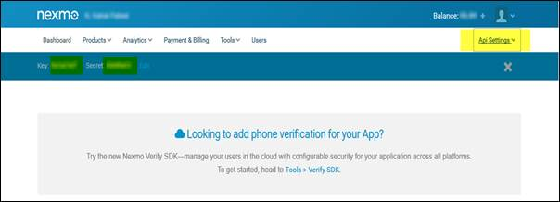

## Limitations

* NexmoUpdate App is hosted on your server so the webhook cannot be created automatically.